COSC 6373: COMPUTER VISION

HOMEWORK-2 REPORT

RAJ SHAH

1499521

TRAINING SET

Positive Images

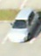  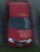 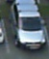 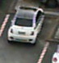 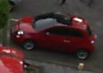 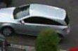 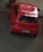

Set of positive images during Sunny Weather of the 2 parking lots.

Negative Images

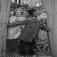    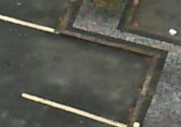 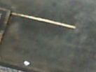  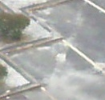

Set of Negative Images which includes empty parking spots and random images

The images are obtained by parsing the xml file using Tinyxml2 parser and saving the cropped images to a directory.

I have used around 3800 positives and 6400 negatives for HAAR Training.

I have used around 5000 positives and 6400 negatives for LBP Training.

Initially I started with 200 positive images and 400 negatives which gave me a very few detections and a lot of false positives thus had to increase the number of positive as well as negative samples.

As training of LBP is fast as compared to HAAR feature, I used more positives to get better detection.

Also, width and height for LBP were 45 and 60 respectively, and for HAAR, 30 and 30 respectively.

PARAMETERS:

cascadeDirName: classifierHAAR

vecFileName: parkinglot.vec

bgFileName: NegativeNew.txt

numPos: 3000

numNeg: 6000

numStages: 15

precalcValBufSize[Mb] : 2048

precalcIdxBufSize[Mb] : 2048

acceptanceRatioBreakValue : -1

stageType: BOOST

featureType: HAAR

sampleWidth: 30

sampleHeight: 30

boostType: GAB

minHitRate: 0.995

maxFalseAlarmRate: 0.5

weightTrimRate: 0.95

maxDepth: 1

maxWeakCount: 100

mode: BASIC

Performance of HAAR after 10 Stages

N HR FA

61 0.995333 0.48033

PARAMETERS:

cascadeDirName: classifierLBP

vecFileName: parkingLBP.vec

bgFileName: NegativeNew.txt

numPos: 3000

numNeg: 6000

numStages: 17

precalcValBufSize[Mb] : 2048

precalcIdxBufSize[Mb] : 2048

acceptanceRatioBreakValue : -1

stageType: BOOST

featureType: LBP

sampleWidth: 45

sampleHeight: 60

boostType: GAB

minHitRate: 0.995

maxFalseAlarmRate: 0.5

weightTrimRate: 0.95

maxDepth: 1

maxWeakCount: 100

Performance of LBP after 17 Stages

N HR FA

13 0.995333 0.463833

The stages chosen allowed to reduce the number of false positives and increase number of true positives or positive detection.

Detection Using Haar Features

Example

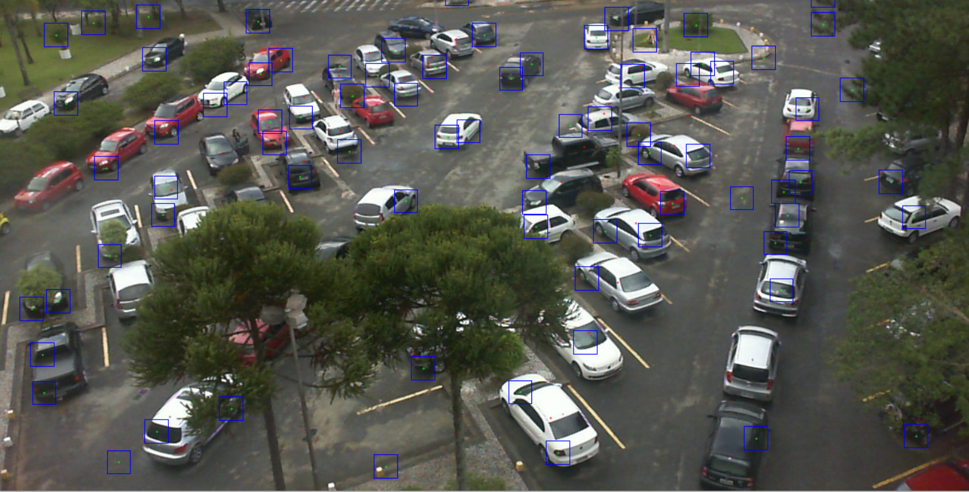

Parking lot 1a

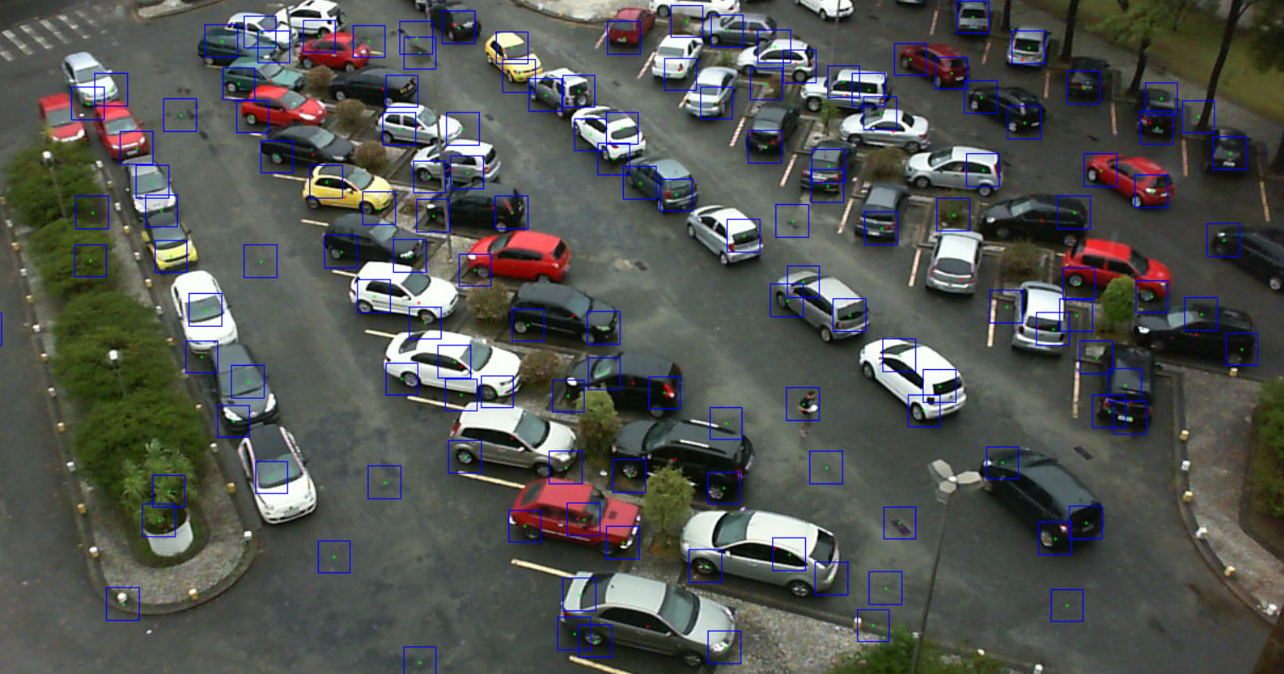

Parking lot 1b

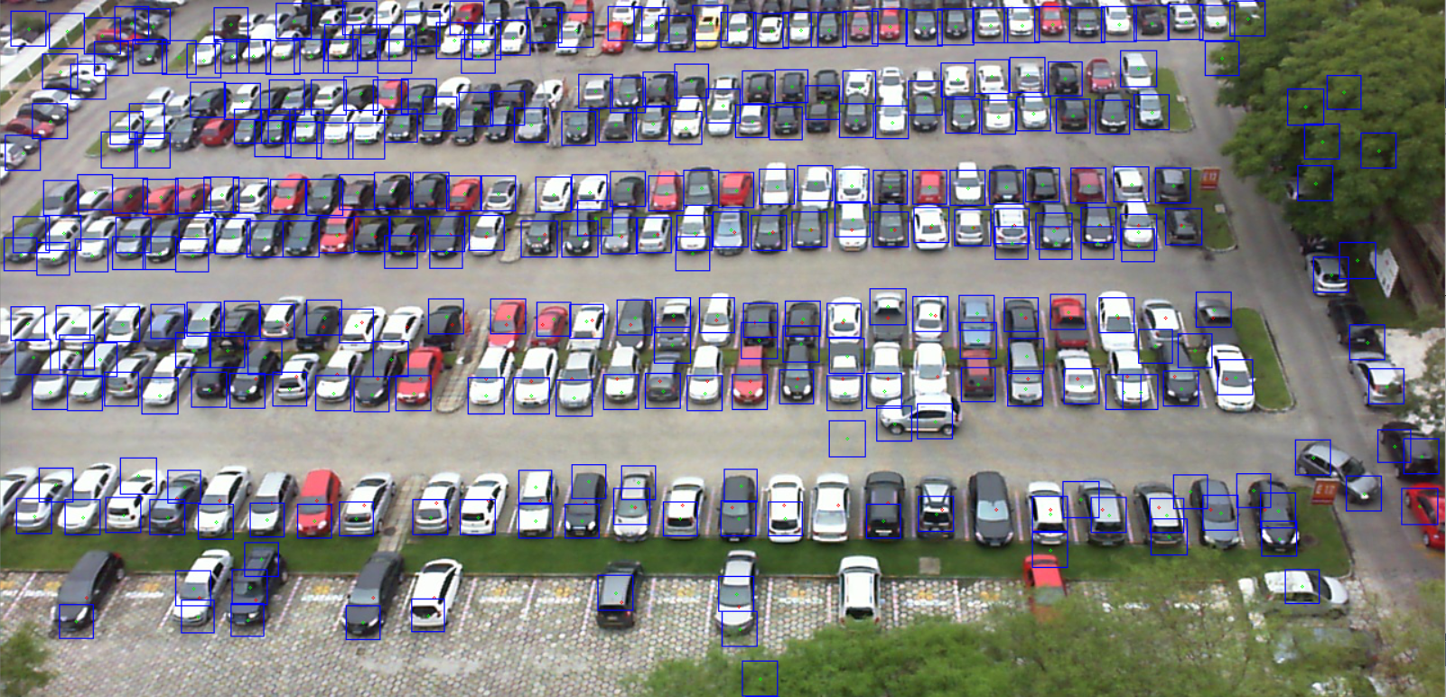

Parking lot 2

Detection Using LBP Features

Example

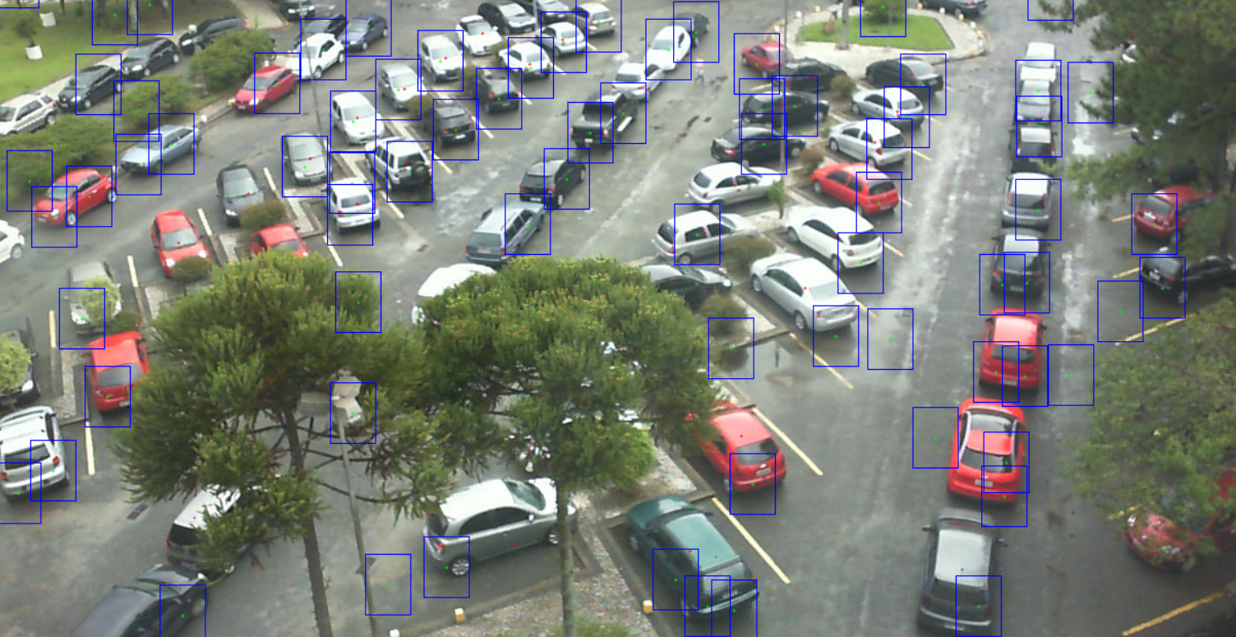

Parking lot 1a

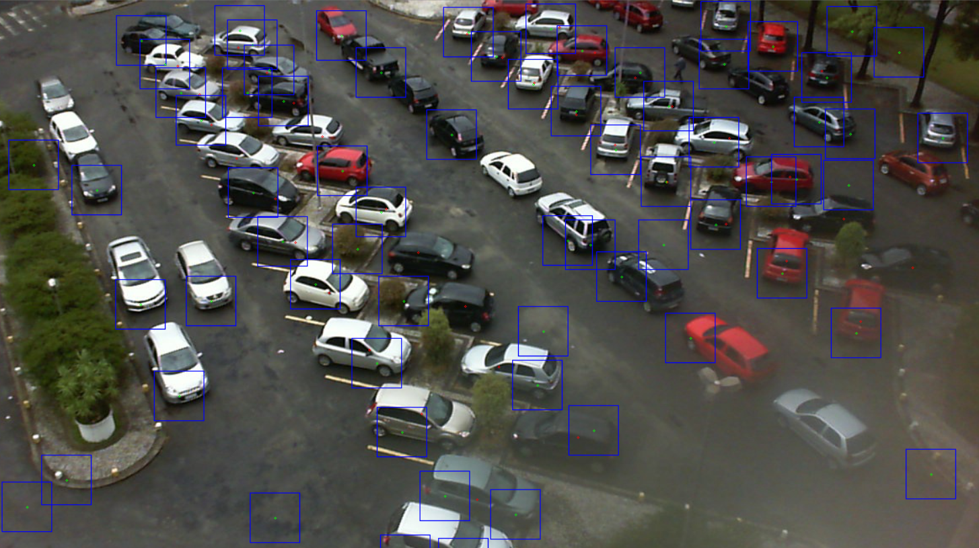

Parking lot 1b

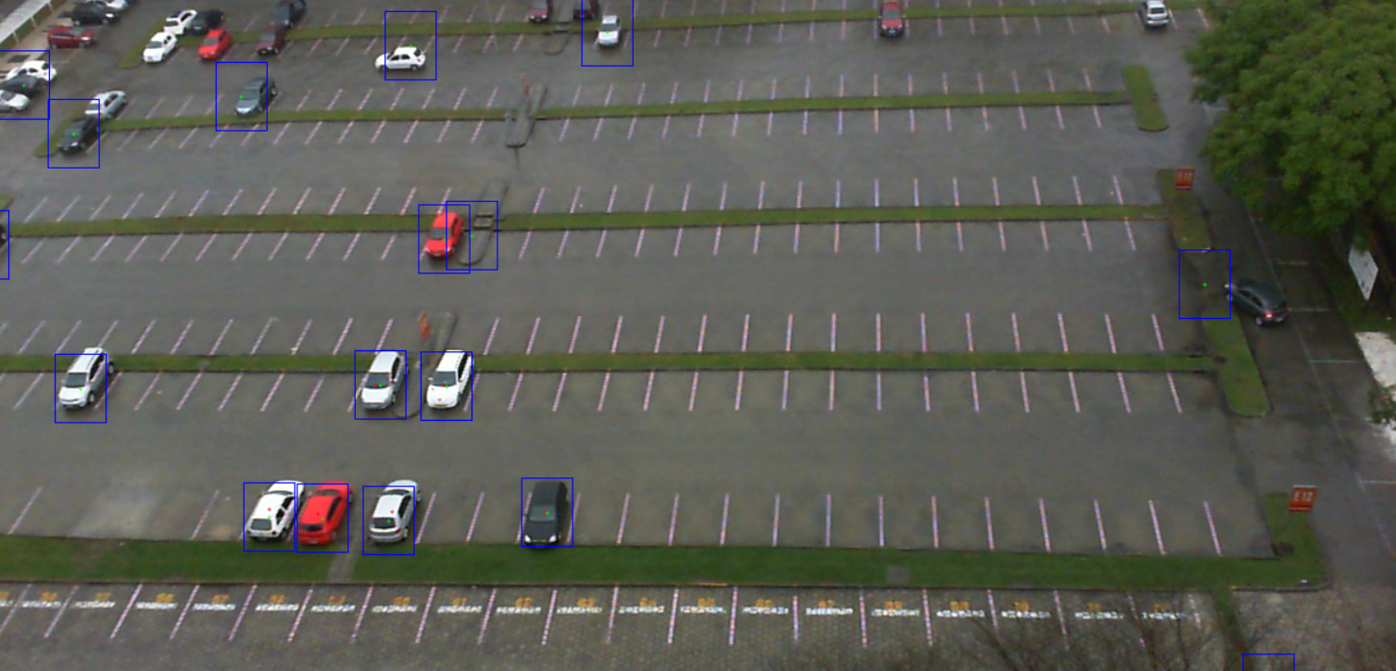

Parking lot 2

Rainy Weather (HAAR Feature Type)

Observations for Parking lot 1

|  |  |  |  |  |  |  |  |
| --- | --- | --- | --- | --- | --- | --- | --- |
| Test  Image | Classifier  Feature | Training | | | TP | FP | Accuracy  (%) |
| Stages | No. of  Positives | No. of  Negatives |
| \\PKLot\\parking1a\\rainy\\2012-12-07\\2012-12-07_17_07_25 | HAAR | 10 | 3876 | 6420 | 26 | 0 | 92.85 |
| \\PKLot\\parking1a\\rainy\\2012-12-08\\2012-12-08_18_25_14 | HAAR | 10 | 3876 | 6420 | 0 | 0 | 100 |
| \\PKLot\\parking1a\\rainy\\2012-12-21\\2012-12-21_21_00_18 | HAAR | 10 | 3876 | 6420 | 6 | 8 | 71.42 |
| \\PKLot\\parking1a\\rainy\\2012-12-11\\2012-12-11_14_51_07 | HAAR | 10 | 3876 | 6420 | 22 | 0 | 82.14 |
| \\PKLot\\parking1a\\rainy\\2012-12-11\\2012-12-11_16_41_09 | HAAR | 10 | 3876 | 6420 | 25 | 0 | 89.28 |
| \\PKLot\\parking1b\\rainy\\2013-03-05\\2013-03-05_13_00_08 | HAAR | 10 | 3876 | 6420 | 35 | 0 | 90.00 |
| \\PKLot\\parking1b\\rainy\\2013-03-05\\2013-03-05_14_05_09 | HAAR | 10 | 3876 | 6420 | 31 | 0 | 77.50 |
| \\PKLot\\parking1b\\rainy\\2013-03-05\\2013-03-05_15_15_10 | HAAR | 10 | 3876 | 6420 | 34 | 0 | 85.00 |
| \\PKLot\\parking1b\\rainy\\2013-04-12\\2013-04-12_17_45_13 | HAAR | 10 | 3876 | 6420 | 12 | 2 | 85.00 |
| \\PKLot\\parking1b\\rainy\\2013-03-20\\2013-03-20_17_45_13 | HAAR | 10 | 3876 | 6420 | 24 | 1 | 84.89 |

Observation for Parking Lot 2

|  |  |  |  |  |  |  |  |
| --- | --- | --- | --- | --- | --- | --- | --- |
| Test  Image | Classifier  Feature | Training | | | TP | FP | Accuracy |
| Stages | No. of  Positives | No. of  Negatives |
| \\PKLot\\parking2\\rainy\\2012-09-21\\2012-09-21_14_00_30 | HAAR | 10 | 3876 | 6420 | 54 | 2 | 98.00 |
| \\PKLot\\parking2\\rainy\\2012-09-21\\2012-09-21_12_20_26 | HAAR | 10 | 3876 | 6420 | 52 | 0 | 99.00 |
| \\PKLot\\parking2\\rainy\\2012-09-21\\2012-09-21_07_50_15 | HAAR | 10 | 3876 | 6420 | 62 | 0 | 98.00 |
| \\PKLot\\parking2\\rainy\\2012-09-21\\2012-09-21_08_15_16 | HAAR | 10 | 3876 | 6420 | 77 | 0 | 88.00 |
| \\PKLot\\parking2\\rainy\\2012-10-26\\2012-10-26_09_09_33 | HAAR | 10 | 3876 | 6420 | 85 | 0 | 90.00 |
| \\PKLot\\parking2\\rainy\\2012-10-26\\2012-10-26_13_39_47 | HAAR | 10 | 3876 | 6420 | 58 | 6 | 93.00 |
| \\PKLot\\parking2\\rainy\\2012-10-26\\2012-10-26_19_15_03 | HAAR | 10 | 3876 | 6420 | 77 | 0 | 77.00 |
| \\PKLot\\parking2\\rainy\\2012-10-26\\2012-10-26_18_35_01 | HAAR | 10 | 3876 | 6420 | 61 | 0 | 96.00 |
| \\PKLot\\parking2\\rainy\\2012-11-10\\2012-11-10_08_47_45 | HAAR | 10 | 3876 | 6420 | 61 | 0 | 92.00 |
| \\PKLot\\parking2\\rainy\\2012-11-09\\2012-11-09_07_01_32 | HAAR | 10 | 3876 | 6420 | 6 | 1 | 99.00 |

Cloudy Weather

Observations for Parking lot 1

|  |  |  |  |  |  |  |  |
| --- | --- | --- | --- | --- | --- | --- | --- |
| Test  Image | Classifier  Feature | Training | | | TP | FP | Accuracy |
| Stages | No. of  Positives | No. of  Negatives |
| \\PKLot\\parking1a\\cloudy\\2012-12-15\\2012-12-15_07_30_02 | HAAR | 10 | 3876 | 6420 | 0 | 0 | 100 |
| \\PKLot\\parking1a\\cloudy\\2012-12-15\\2012-12-15_09_45_05 | HAAR | 10 | 3876 | 6420 | 5 | 12 | 46.42 |
| \\PKLot\\parking1a\\cloudy\\2012-12-12\\2012-12-12_10_55_06 | HAAR | 10 | 3876 | 6420 | 26 | 0 | 96.4286 |
| \\PKLot\\parking1a\\cloudy\\2012-12-14\\2012-12-14_09_15_04 | HAAR | 10 | 3876 | 6420 | 24 | 0 | 85.7143 |
| \\PKLot\\parking1a\\cloudy\\2012-12-14\\2012-12-14_20_55_18 | HAAR | 10 | 3876 | 6420 | 17 | 5 | 78.5714 |
| \\PKLot\\parking1b\\cloudy\\2013-02-26\\2013-02-26_13_24_34 | HAAR | 10 | 3876 | 6420 | 34 | 0 | 85.00 |
| \\PKLot\\parking1b\\cloudy\\2013-02-26\\2013-02-26_14_49_35 | HAAR | 10 | 3876 | 6420 | 32 | 0 | 80.00 |
| \\PKLot\\parking1b\\cloudy\\2013-02-26\\2013-02-26_17_24_38 | HAAR | 10 | 3876 | 6420 | 28 | 1 | 80.00 |
| \\PKLot\\parking1b\\cloudy\\2013-03-02\\2013-03-02_06_05_00 | HAAR | 10 | 3876 | 6420 | 0 | 0 | 100 |
| \\PKLot\\parking1b\\cloudy\\2013-03-18\\2013-03-18_18_10_14 | HAAR | 10 | 3876 | 6420 | 19 | 6 | 67.50 |

Observation for Parking Lot 2

|  |  |  |  |  |  |  |  |
| --- | --- | --- | --- | --- | --- | --- | --- |
| Test  Image | Classifier  Feature | Training | | | TP | FP | Accuracy |
| Stages | No. of  Positives | No. of  Negatives |
| \\PKLot\\parking2\\cloudy\\2012-09-12\\2012-09-12_07_54_56 | HAAR | 10 | 3876 | 6420 | 82 | 0 | 92.00 |
| \\PKLot\\parking2\\cloudy\\2012-09-12\\2012-09-12_09_08_18 | HAAR | 10 | 3876 | 6420 | 88 | 0 | 93.00 |
| \\PKLot\\parking2\\cloudy\\2012-09-12\\2012-09-12_06_15_44 | HAAR | 10 | 3876 | 6420 | 0 | 0 | 100 |
| \\PKLot\\parking2\\cloudy\\2012-09-12\\2012-09-12_10_26_57 | HAAR | 10 | 3876 | 6420 | 86 | 0 | 95.00 |
| \\PKLot\\parking2\\cloudy\\2012-10-16\\2012-10-16_05_46_42 | HAAR | 10 | 3876 | 6420 | 1 | 0 | 100 |
| \\PKLot\\parking2\\cloudy\\2012-10-16\\2012-10-16_07_36_46 | HAAR | 10 | 3876 | 6420 | 43 | 1 | 98.00 |
| \\PKLot\\parking2\\cloudy\\2012-10-16\\2012-10-16_13_53_43 | HAAR | 10 | 3876 | 6420 | 64 | 1 | 97.00 |
| \\PKLot\\parking2\\cloudy\\2012-09-28\\2012-09-28_08_31_04 | HAAR | 10 | 3876 | 6420 | 86 | 0 | 96.00 |
| \\PKLot\\parking2\\cloudy\\2012-09-28\\2012-09-28_18_11_31 | HAAR | 10 | 3876 | 6420 | 47 | 2 | 97.00 |
| \\PKLot\\parking2\\cloudy\\2012-09-28\\2012-09-28_17_31_29 | HAAR | 10 | 3876 | 6420 | 60 | 2 | 97.00 |

Rainy Weather (LBP Feature Type)

Observations for Parking lot 1

|  |  |  |  |  |  |  |  |
| --- | --- | --- | --- | --- | --- | --- | --- |
| Test  Image | Classifier  Feature | Training | | | TP | FP | Accuracy |
| Stages | No. of  Positives | No. of  Negatives |
| \\PKLot\\parking1a\\rainy\\2012-12-08\\2012-12-08_18_30_15 | LBP | 17 | 5026 | 6420 | 0 | 0 | 100 |
| \\PKLot\\parking1a\\rainy\\2012-12-11\\2012-12-11_15_46_08 | LBP | 17 | 5026 | 6420 | 23 | 0 | 82.1429 |
| \\PKLot\\parking1a\\rainy\\2012-12-11\\2012-12-11_16_56_09 | LBP | 17 | 5026 | 6420 | 22 | 1 | 78.5714 |
| \\PKLot\\parking1a\\rainy\\2012-12-07\\2012-12-07_16_52_25 | LBP | 17 | 5026 | 6420 | 19 | 0 | 67.8571 |
| \\PKLot\\parking1a\\rainy\\2012-12-07\\2012-12-07_16_47_25 | LBP | 17 | 5026 | 6420 | 18 | 0 | 64.2857 |
| \\PKLot\\parking1b\\rainy\\2013-02-26\\2013-02-26_13_04_33 | LBP | 20 | 642 | 1071 | 35 | 0 | 87.5 |
| \\PKLot\\parking1b\\rainy\\2013-02-26\\2013-02-26_13_19_33 | LBP | 20 | 642 | 1071 | 32 | 0 | 82.5 |
| \\PKLot\\parking1b\\rainy\\2013-03-13\\2013-03-13_13_25_08 | LBP | 20 | 642 | 1071 | 33 | 0 | 82.5 |
| \\PKLot\\parking1b\\rainy\\2013-03-13\\2013-03-13_14_10_09 | LBP | 20 | 642 | 1071 | 30 | 0 | 77.5 |
| \\PKLot\\parking1b\\rainy\\2013-03-13\\2013-03-13_15_30_11 | LBP | 20 | 642 | 1071 | 32 | 0 | 82.5 |

Observation for Parking Lot 2

|  |  |  |  |  |  |  |  |
| --- | --- | --- | --- | --- | --- | --- | --- |
| Test  Image | Classifier  Feature | Training | | | TP | FP | Accuracy |
| Stages | No. of  Positives | No. of  Negatives |
| \\PKLot\\parking2\\rainy\\2012-10-11\\2012-10-11_10_56_39 | LBP | 17 | 5026 | 6420 | 83 | 0 | 93.00 |
| \\PKLot\\parking2\\rainy\\2012-10-11\\2012-10-11_07_57_16 | LBP | 17 | 5026 | 6420 | 62 | 0 | 99.00 |
| \\PKLot\\parking2\\rainy\\2012-10-11\\2012-10-11_08_46_33 | LBP | 17 | 5026 | 6420 | 90 | 0 | 96.00 |
| \\PKLot\\parking2\\rainy\\2012-10-11\\2012-10-11_12_31_44 | LBP | 17 | 5026 | 6420 | 48 | 3 | 97.00 |
| \\PKLot\\parking2\\rainy\\2012-09-16\\2012-09-16_06_32_55 | LBP | 17 | 5026 | 6420 | 0 | 3 | 97.00 |
| \\PKLot\\parking2\\rainy\\2012-09-16\\2012-09-16_07_52_58 | LBP | 17 | 5026 | 6420 | 3 | 1 | 99.00 |
| \\PKLot\\parking2\\rainy\\2012-09-21\\2012-09-21_08_00_15 | LBP | 17 | 5026 | 6420 | 78 | 1 | 98.00 |
| \\PKLot\\parking2\\rainy\\2012-09-21\\2012-09-21_07_10_13 | LBP | 17 | 5026 | 6420 | 7 | 2 | 98.00 |
| \\PKLot\\parking2\\rainy\\2012-09-21\\2012-09-21_13_00_27 | LBP | 17 | 5026 | 6420 | 44 | 3 | 97.00 |
| \\PKLot\\parking2\\rainy\\2012-09-21\\2012-09-21_14_00_30 | LBP | 17 | 5026 | 6420 | 53 | 5 | 94.00 |

Cloudy Weather

Observations for Parking lot 1

|  |  |  |  |  |  |  |  |
| --- | --- | --- | --- | --- | --- | --- | --- |
| Test  Image | Classifier  Feature | Training | | | TP | FP | Accuracy |
| Stages | No. of  Positives | No. of  Negatives |
| \\PKLot\\parking1a\\cloudy\\2012-12-14\\2012-12-14_09_15_04 | LBP | 17 | 5026 | 6420 | 25 | 0 | 89.2857 |
| \\PKLot\\parking1a\\cloudy\\2012-12-14\\2012-12-14_09_35_05 | LBP | 17 | 5026 | 6420 | 24 | 1 | 85.7143 |
| \\PKLot\\parking1a\\cloudy\\2012-12-14\\2012-12-14_19_40_17 | LBP | 17 | 5026 | 6420 | 22 | 3 | 85.7143 |
| \\PKLot\\parking1a\\cloudy\\2012-12-14\\2012-12-14_18_20_15 | LBP | 17 | 5026 | 6420 | 16 | 4 | 71.4286 |
| \\PKLot\\parking1a\\cloudy\\2012-12-12\\2012-12-12_10_00_05 | LBP | 17 | 5026 | 6420 | 25 | 0 | 85.7143 |
| \\PKLot\\parking1b\\cloudy\\2013-02-26\\2013-02-26_13_24_34 | LBP | 20 | 642 | 1071 | 38 | 0 | 95.00 |
| \\PKLot\\parking1b\\cloudy\\2013-02-26\\2013-02-26_13_34_34 | LBP | 20 | 642 | 1071 | 33 | 0 | 82.5 |
| \\PKLot\\parking1b\\cloudy\\2013-02-26\\2013-02-26_14_24_35 | LBP | 20 | 642 | 1071 | 31 | 0 | 77.5 |
| \\PKLot\\parking1b\\cloudy\\2013-02-26\\2013-02-26_14_49_35 | LBP | 20 | 642 | 1071 | 33 | 0 | 82.5 |
| \\PKLot\\parking1b\\cloudy\\2013-02-26\\2013-02-26_15_44_36 | LBP | 20 | 642 | 1071 | 29 | 0 | 72.5 |

Observation for Parking Lot 2

|  |  |  |  |  |  |  |  |
| --- | --- | --- | --- | --- | --- | --- | --- |
| Test  Image | Classifier  Feature | Training | | | TP | FP | Accuracy |
| Stages | No. of  Positives | No. of  Negatives |
| \\PKLot\\parking2\\cloudy\\2012-09-28\\2012-09-28_07_16_00 | LBP | 17 | 5026 | 6420 | 13 | 7 | 93.00 |
| \\PKLot\\parking2\\cloudy\\2012-09-28\\2012-09-28_12_26_15 | LBP | 17 | 5026 | 6420 | 48 | 8 | 90.00 |
| \\PKLot\\parking2\\cloudy\\2012-09-28\\2012-09-28_17_26_29 | LBP | 17 | 5026 | 6420 | 60 | 6 | 91.00 |
| \\PKLot\\parking2\\cloudy\\2012-09-12\\2012-09-12_09_50_14 | LBP | 17 | 5026 | 6420 | 90 | 0 | 97.00 |
| \\PKLot\\parking2\\cloudy\\2012-09-12\\2012-09-12_08_05_25 | LBP | 17 | 5026 | 6420 | 87 | 0 | 92.00 |
| \\PKLot\\parking2\\cloudy\\2012-09-28\\2012-09-28_11_06_11 | LBP | 17 | 5026 | 6420 | 86 | 1 | 97.00 |
| \\PKLot\\parking2\\cloudy\\2012-09-16\\2012-10-16_06_01_42 | LBP | 17 | 5026 | 6420 | 2 | 0 | 100 |
| \\PKLot\\parking2\\cloudy\\2012-09-16\\2012-10-16_09_08_28 | LBP | 17 | 5026 | 6420 | 94 | 0 | 98.00 |
| \\PKLot\\parking2\\cloudy\\2012-09-16\\2012-10-16_11_18_35 | LBP | 17 | 5026 | 6420 | 76 | 1 | 96.00 |
| \\PKLot\\parking2\\cloudy\\2012-09-12\\2012-09-12_09_55_29 | LBP | 17 | 5026 | 6420 | 89 | 0 | 94.00 |

I have used a separate classifier for lot 1b as the results with combined classifier were not very accurate. So, I used around 640 positives and 1071 negatives to create a classifier for parking lot 1b.

The width and height used for training is 60 and 60 respectively.